**DVS System Deployment Process**

# Preparation

* 1. Turn off all unnecessary software and firewall on your PC.
  2. Network Switch (layer 3) setup: (For example: S5048PV3 from H3C with PoE)
     1. Turn on: **multicast**

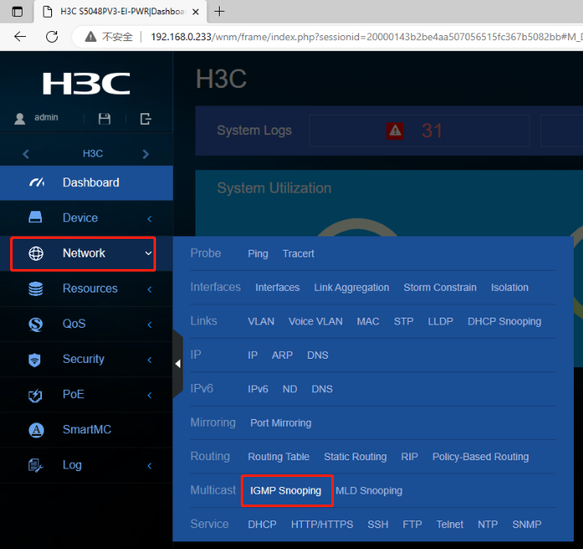

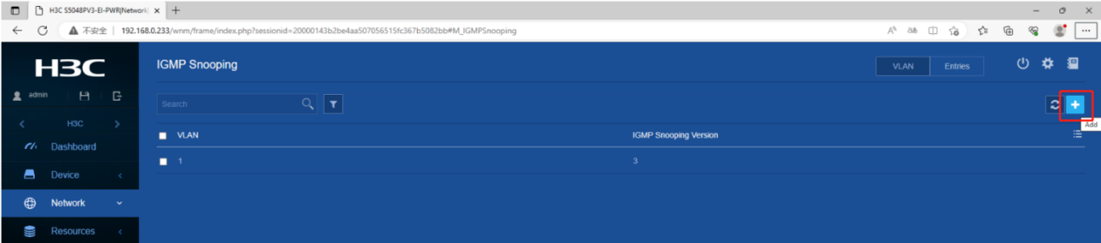

* + 1. IGMP Snooping on VLAN
       1. Dis-select: Enable dropping unknown multicast data
       2. Select: Act as lGMP querier, set to 5 seconds.

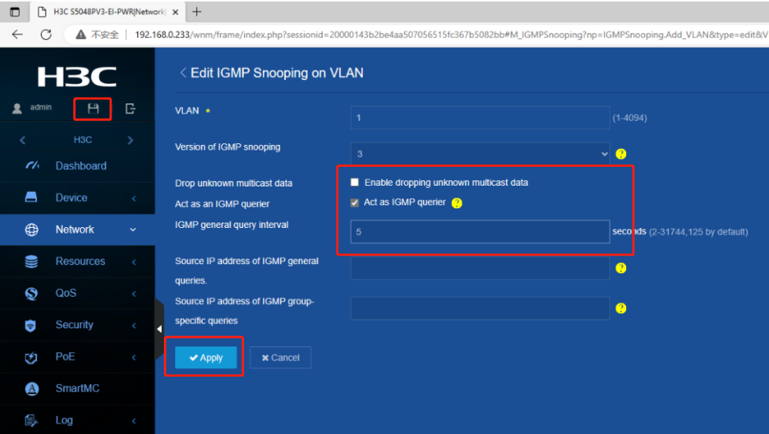

* + 1. Turn on: DHCP (if necessary)

# Wiring Diagram

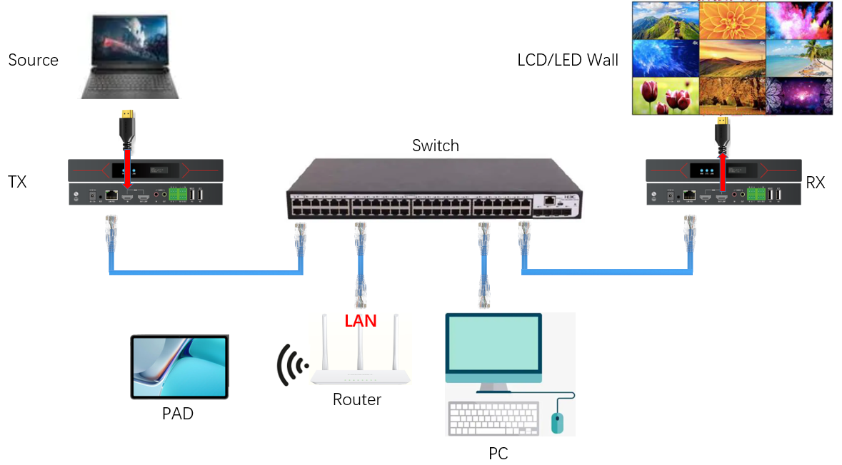

# Installation

* 1. Network Switch with PoE
     1. Doesn’t need the 12V/1A power supply adapter.
     2. Connects all RJ45 and HDMI cables.
     3. Turn on the whole system, and wait for the Network Switch power up.
     4. Run PC tool: <http://www.lytch.net/MVWP/DVStool/DVSTool-pc.zip>
     5. Set IP address:

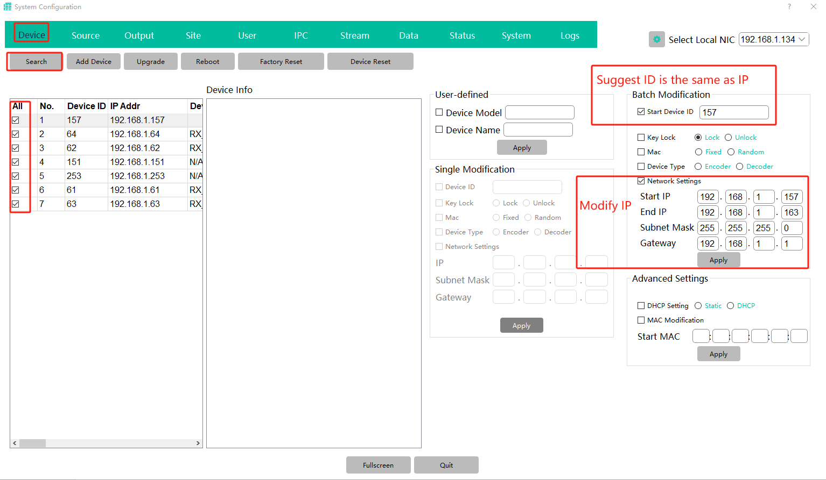

* + 1. Set SS4K30/HS4K30 to work as Encoder **OR** Decoder

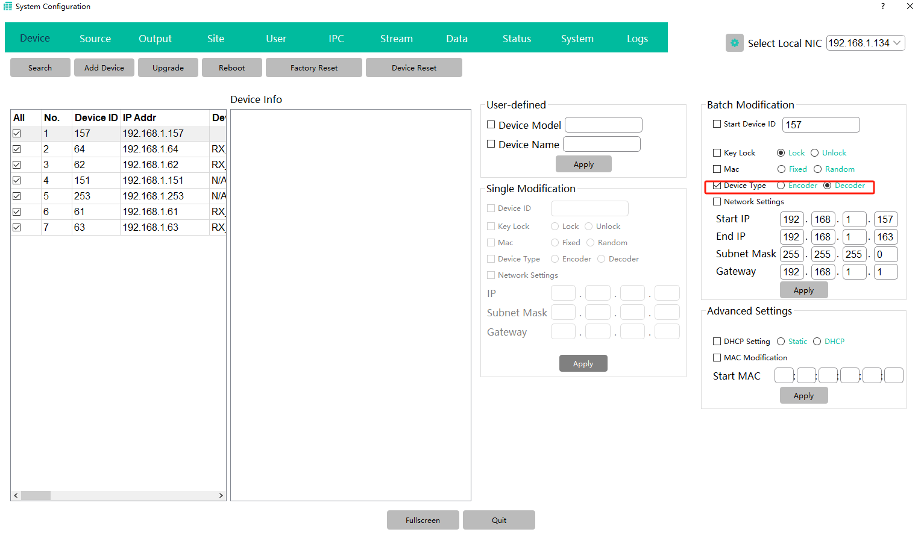

* + 1. Set Source(Encoder)

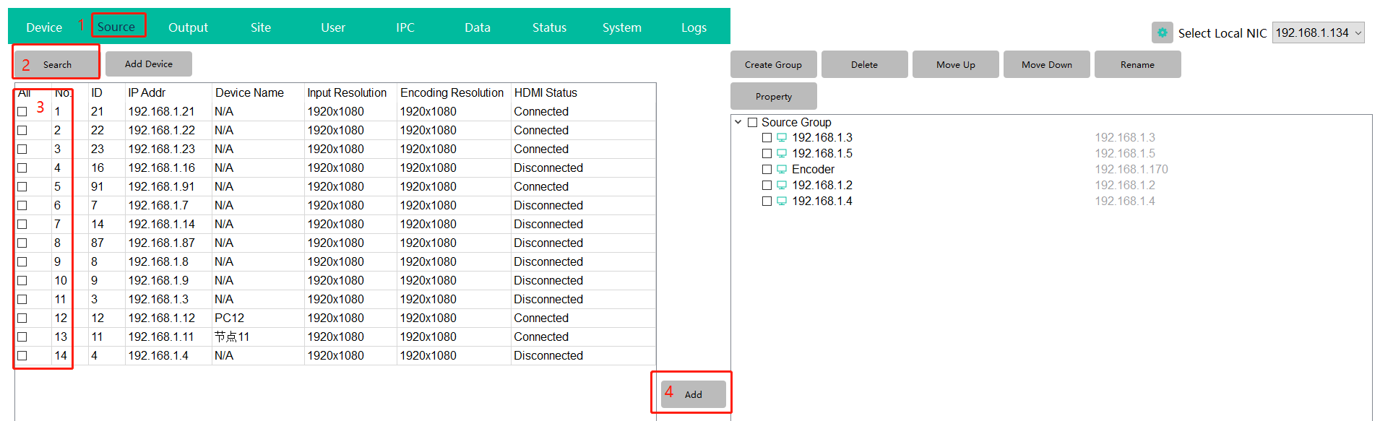

* + 1. Set Output(Decoder)

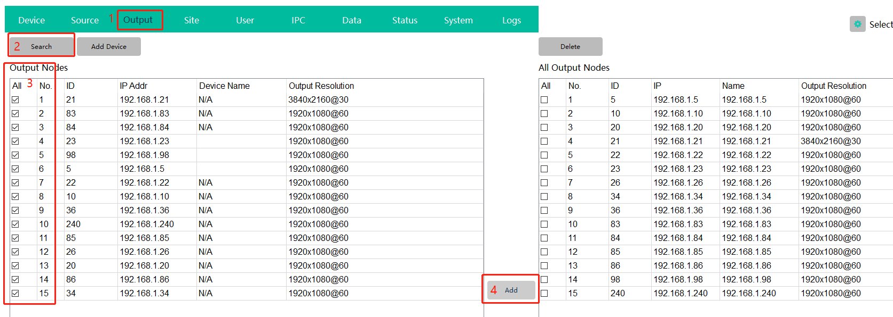

* + 1. If you want use iOS/Android, set a WiFi access point as wiring diagram, then install and run iOS/Android tool

iOS App Store: DVSTool

Android: http://www.lytch.net/MVWP/DVStool/DVSTool-android.zip

* 1. Network Switch without PoE
     1. Plug in 12V/1A power supply adapter of all nodes.
     2. Same as 3.1

# User Interface (PC, iOS, Android)

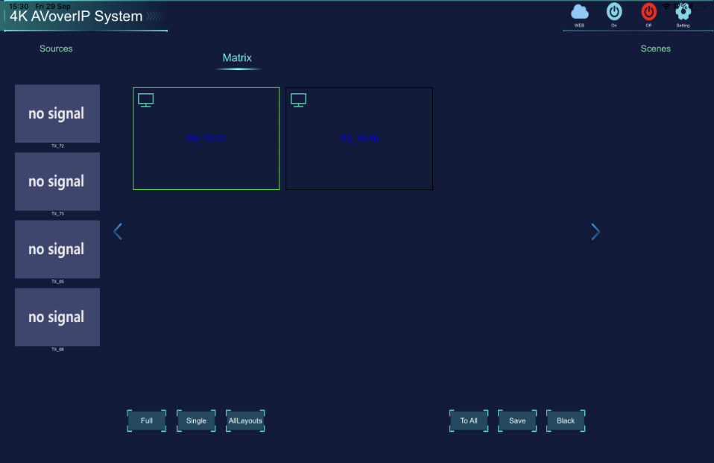

# LCD Video Wall

